  Checkpoint II | Checkpoint II: Visualization Sketch
 | Group: | G16
 | Date: | 2025/09/23

Dashboard Overview
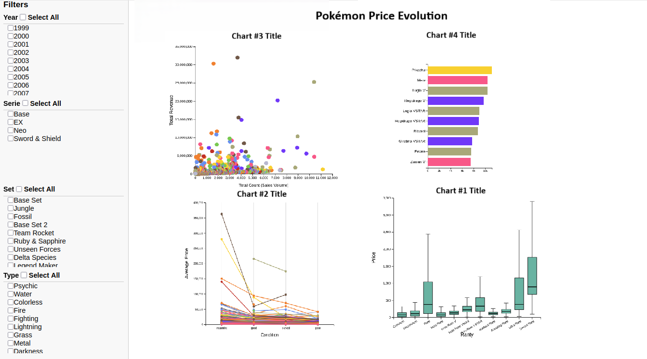
The dashboard features a set of stacked checkbox filters on the left, allowing the user to select multiple options for year, series, set, and type to customize the data view. All graphs update according to the same filtered data. If the selected filters yield no results, no charts are displayed; with no filters selected, all available data is shown. The top-left section displays a scatter plot of the filtered data, accompanied by a horizontal bar chart showing the top 10 most popular Pokémon. Below, the left side features a slopegraph comparing prices across types, while the bottom-right section presents a grouped box plot for price comparisons across rarities.

Charts
The dashboard uses three complementary visual idioms—box plots, slopegraphs, and scatterplots with bar charts—to explore card rarity, condition, popularity, and value across series, sets, types, and years.

Chart #1 (Grouped Box Plot)
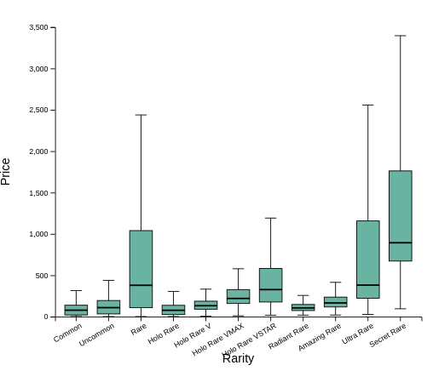
Task 2: Do rarities influence price the same way by type, by set and by year?
We decided to use a Grouped Box Plot because it clearly shows the distribution of prices across rarity levels, not just averages. This is important since card prices can be highly skewed. By grouping box plots by set, type, or year (depending on user selection), users can compare how the relationship between rarity and price changes across contexts. Alternatively, we could have used a heatmap (rarity × type with color = avg price), but that would only display central tendencies, not the spread or variability. We could also have used a slopegraph to show average price trends by rarity, but this would oversimplify the underlying distributions and hide important market dynamics.

Marks and Channels
Marks:
- Rectangles (boxes) for interquartile ranges (Q1–Q3).
- Horizontal lines inside boxes (median).
- Vertical whiskers (min/max excluding outliers).
Visual channels:
- Position (X-axis): encodes rarity (ordinal).
- Position (Y-axis): encodes price (quantitative, ratio).
- Grouping (facets): by type, series, set, or release year.

Rationale
The grouped box plot is well-suited here because it allows comparison across categories (rarities) while capturing both central tendency (median, quartiles) and variability (whiskers, outliers). This matches the task abstraction of testing consistency: if rarities consistently influence price, the medians and distributions should form similar patterns across series/sets/years. Outliers are especially important in collectible markets, where a single iconic card may distort averages. This idiom preserves that information, unlike simpler summary charts.

Interaction
- Hover: Highlight card, Show exact stats (median, mean, quartiles, min, max) for each rarity box.
- Click: Highlight card across other idioms

Chart #2 (Grouped Slopegraph)
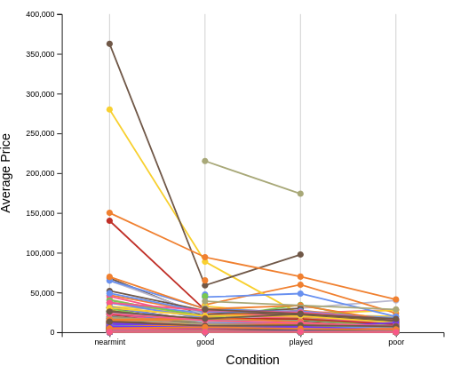
Task 3: Does condition consistently affect price across types, sets and years?
We decided to use a Grouped Slopegraph where each card is represented by its own line, connecting its average prices across conditions (Mint → Near Mint → Good, etc.). This idiom is ideal because it lets users compare within a set/type/year: if all cards show parallel slopes, the condition effect is consistent; if some lines are much steeper or flatter, we immediately see which cards behave differently. Alternatively, a parallel coordinates plot could encode the same data, but with many cards it becomes cluttered, and comparing slopes between adjacent axes is less intuitive than direct connections.

Marks and Channels
Marks:
- Lines: One per card, connecting its prices across conditions.
- Points: at each condition step to mark average price values.
Visual channels:
- X-axis (position): Condition (ordinal: Mint, Near Mint, Good …).
- Y-axis (position): Average price (quantitative,ratio).
- Line slope: Encodes relative drop (steeper = larger decline).
- Grouping: Facets or grouped slopegraphs per series, set, type, and year.

Rationale
Using one line per card makes it possible to directly evaluate whether the price-drop pattern is consistent across multiple cards in the same grouping. If the slopes are aligned (similar angles), then condition effects are uniform. Divergent slopes immediately highlight exceptions (e.g., a card whose price collapses when condition worsens vs. a card that holds value even in poor condition). This idiom leverages our strong perceptual ability to detect slope differences and parallelism.

Interaction
- Hover: Highlight card, Show card name + exact price per condition + drop ratios.
- Click: Highlight card across other idioms

Chart #3+4 (Scatter Plot + Top 10 Horizontal Bar Chart)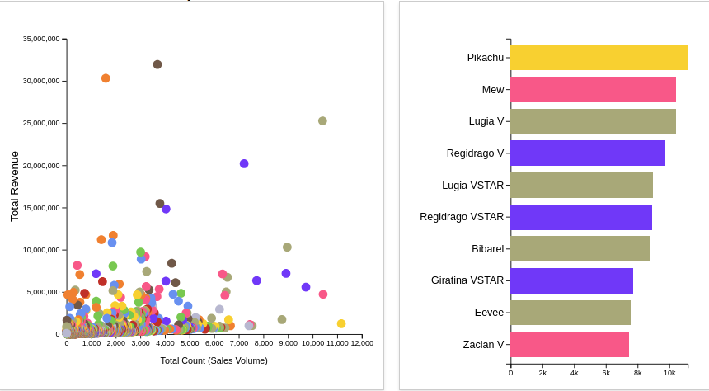
Task 1: Are there any favorite or more popular cards per set and per type?
Task 4: Does type influence the popularity and price of a card by set and by year?
Task 5: Pokémon Card Sales Volume vs. Revenue per Year, Type, Rarity and Name?
We decided to use a Scatter Plot combined with a supporting Top 10 Horizontal Bar Chart because together they provide both a broad market view and precise rankings. The scatter plot captures the relationship between popularity (sales count) and profitability (revenue) across card types, sets, rarities, and years, making it ideal for Tasks 4 and 5. To also address Task 1, we added a Top 10 bar chart that highlights the most popular cards for a selected type or set, since rankings are more easily interpreted with bars than with scatter plots. Alternatively, we could have used a bubble chart to encode rarity with bubble size or a heatmap to show intensity patterns of popularity and value across categories. However, bubble charts rely on less precise area comparisons, and heatmaps obscure exact rankings, which are central to identifying favorites.

Marks and Channels
Marks:
- Dots (scatter plot: each representing a card or aggregated by type/year).
- Rectangles (bars in the Top 10 chart).
Visual channels:
- Scatter Plot:
  - X-axis → Count (sales volume, quantitative, ratio).
  - Y-axis → Revenue (count × avg, quantitative, ratio).
  - Color → Pokémon Type (nominal).
  - Shape (optional) → Rarity (ordinal).
  - Filtering → set/type.
- Bar Chart (Top 10):
  - Length (x-axis) → Count (sales volume).
  - Position (y-axis) → Card name (nominal).
  - Color → Same as the one in the scatterplot.
  - Order → most popular on the top

Rationale
The scatter plot leverages position on a common scale, which is the most accurate channel for comparing quantitative values, making it ideal for detecting correlations and outliers (e.g., high-revenue but low-volume cards). It supports Task 4 by showing whether type influences popularity/value across sets/years and Task 5 by revealing whether high-volume cards are also the most profitable. However, scatter plots are less effective for ranking specific items, which is why the Top 10 bar chart is added to cover Task 1. Bar charts use length (also highly accurate perceptually) and give users a direct ranking of the most popular cards in the selected category. By combining the two idioms, we support exploration at both the macro level (scatter plot trends) and the micro level (Top 10 rankings), ensuring the dashboard addresses all three tasks cohesively.

Interaction
- Hover: Highlight card, Show card relevant details.
- Click: Highlight card across other idioms

Chart Integration

Overview
The dashboard integrates the three chosen visual idioms (Grouped Box Plot, Grouped Slopegraph, Scatter Plot + Top 10 Bar Chart) into a coordinated system. Instead of working in isolation, the charts are linked through shared encodings, interactions, and filters. This ensures that exploration flows seamlessly: a selection in one chart dynamically updates the others, supporting both high-level trends and detailed card-level analysis.

Marks and Channels
- Color (nominal): Pokémon type is encoded with the same color scheme across scatter, bar, box, and slopegraph, ensuring cross-chart recognition.
- Position (ordinal): Rarity and Condition maintain a fixed ordering across all views (e.g., Mint → Near Mint → Good), avoiding cognitive dissonance.
- Shape/Highlighting: Shared encodings allow the same card to be recognized across charts when highlighted or clicked.

Interaction and Coordination

Cross-filtering:
- Selecting a year, set, rarity or name(s) affects all charts globally, updating all charts simultaneously.

Hover:
- Hovering over a point in the scatter highlights the corresponding bar if it appears in the Top 10 ranking, and dims unrelated marks.
- Hovering over a point in the scatter plot highlights the the corresponding card in each other graph or corresponding set/year/type if the other graphs are filtered in those modes

Click/Select:
- Clicking a bar in the Top 10 chart highlights that card across all charts, showing its position in the scatter and its slope in the condition view.

Rationale
The integration transforms the dashboard into more than the sum of its parts. Each idiom addresses a different abstraction (distribution, consistency, correlation, ranking), and integration allows users to combine these perspectives fluidly. For example:
- A user identifies a high-revenue but low-popularity card in the scatter.
- By clicking it, the dashboard highlights its condition slope (slopegraph) and distribution of rarity prices (box plot).
- If the card is also in the Top 10 bar chart, the user immediately sees how it ranks compared to others in the same set/type.

Answering the Questions
- 1: Favorite or popular cards per set/type – Filter by set or type and view the Top 10 Bar Chart for most sold cards, with details available on hover and cross-referenced in the scatter plot.
- 2: Do rarities influence price? – Use the Box Plot, switch context by set/type/year, and compare medians and spreads across rarity levels.
- 3: Does wear quality affect price? – Use the Slopegraph, filter by set or year, and compare line slopes to see how condition changes value.
- 4: Does type influence popularity/price? – Use the Scatter Plot (volume vs. revenue, color = type), filter by set or year, and compare clusters to identify type effects.
- 5: Best-selling cards per year/type/rarity – Filter the Scatter Plot by year, type, and rarity to spot top cards, then confirm rankings in the Top 10 Bar Chart.

Storyboards
For the storyboard, we chose Task 4: “Does type influence the popularity and price of a card by set and by year?” The user begins by exploring the scatter plot and, if needed, filter it to display only a specific set of Pokémon. On the right side, a bar chart shows the top 10 most popular cards from the filtered view, allowing the user to identify any standout types. Selecting a Pokémon in any graph highlights it across all other charts for deeper analysis.

Missed Opportunities
In Checkpoint I, we did not account for the fact that Pokémon sets within the same series can have different release years, which made it harder to evaluate cards consistently. For Checkpoint II, we addressed this by introducing series as an additional filter type. Filters are now stackable, and multiple filters of the same kind can be applied at once, giving users more flexibility to explore subsets of the data. This was a missed opportunity in our initial design but has been resolved in the updated dashboard.

